Cadorna, Joeffrey 6/25/2026
BSCS – 2 (CBM)
- Array in PHP
Act 1
Source Code
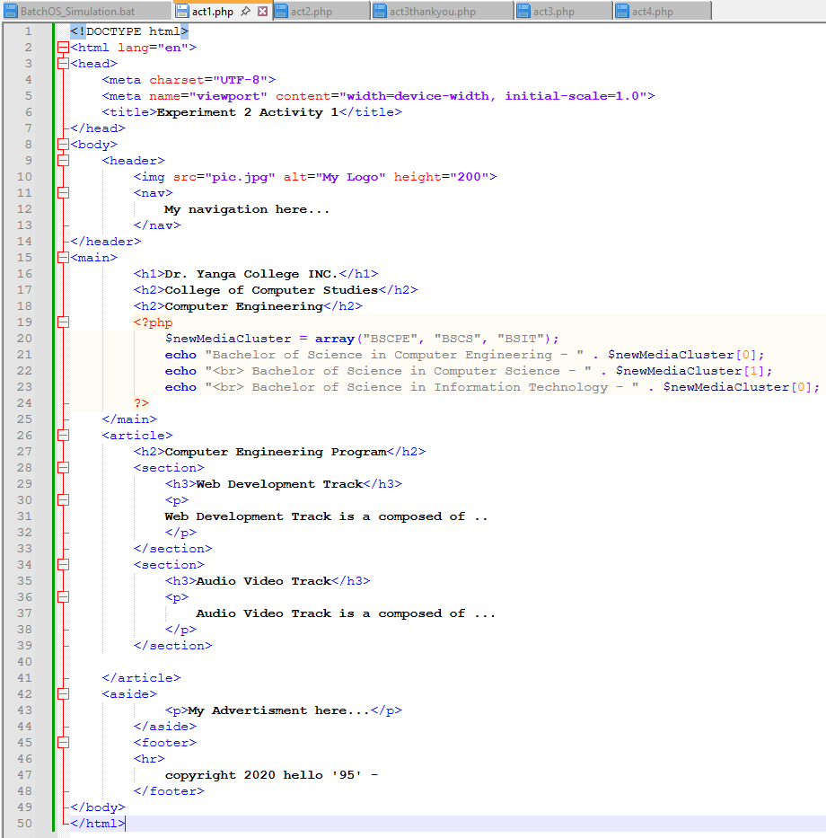

Browser Output
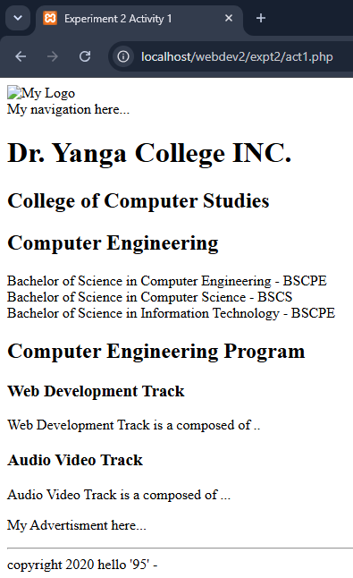

Act 2
Source Code
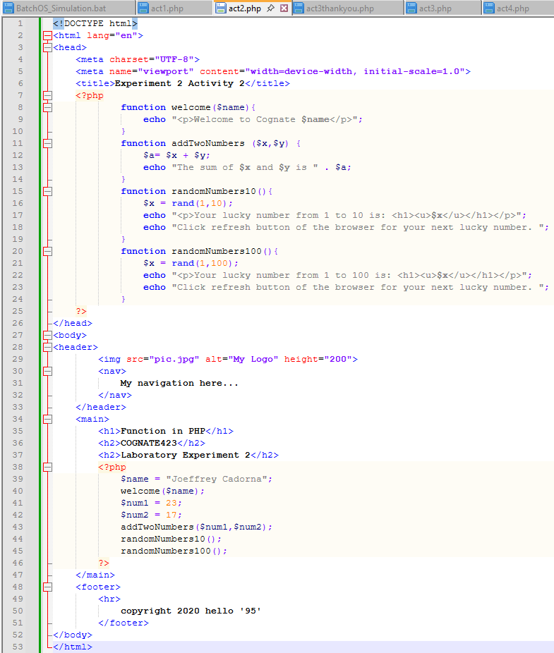

Browser Output
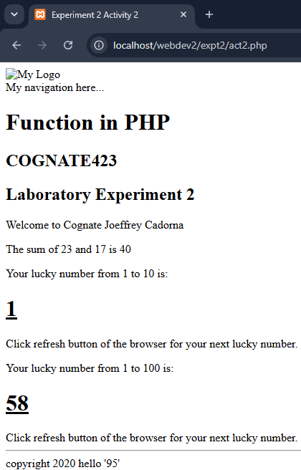

Act3
Source Code
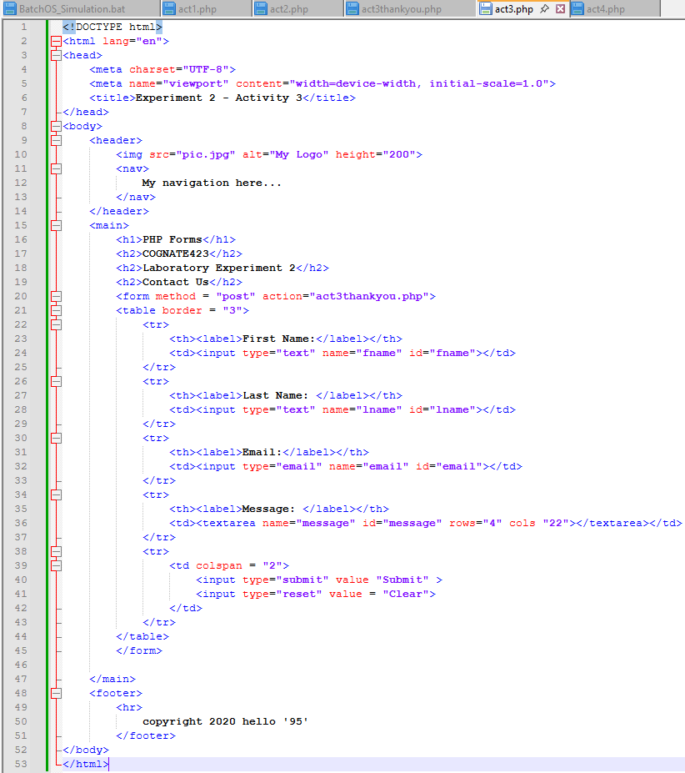

Browser Output
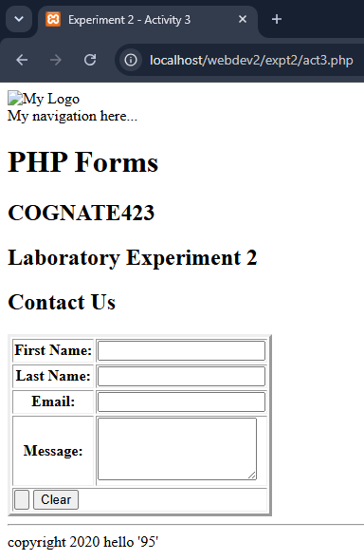

Act3ThankYou
Source Code
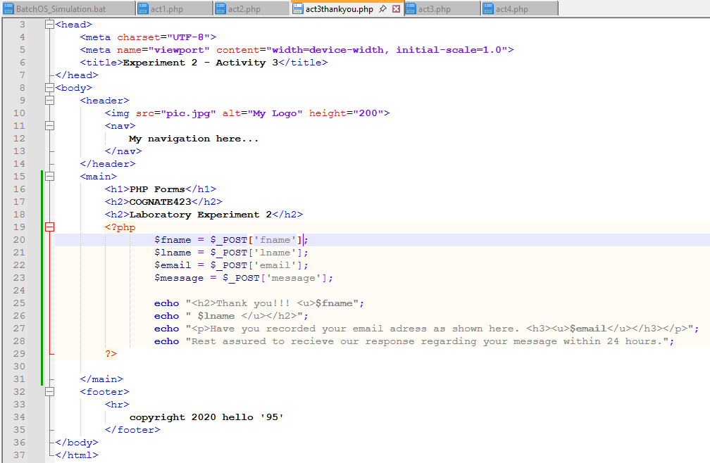
Browser Output
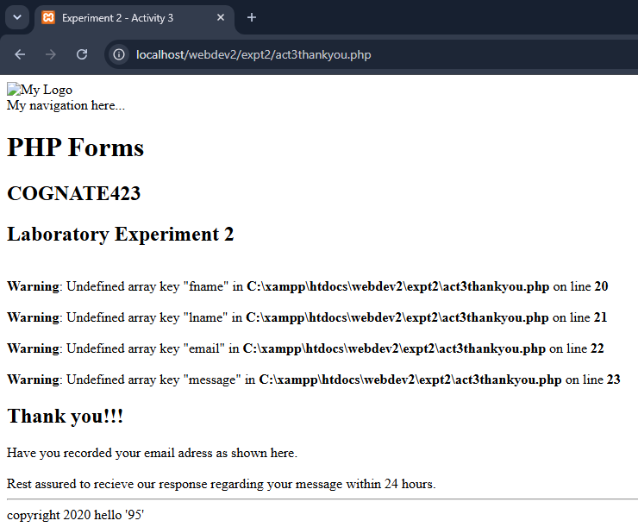

Act4
Source Code
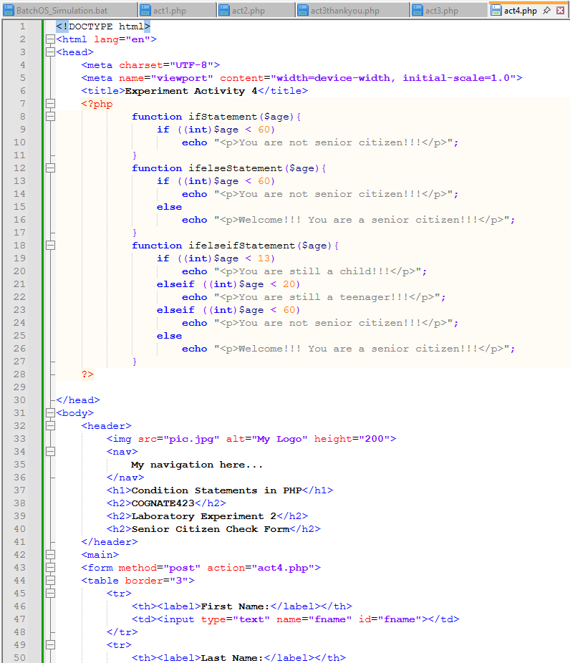
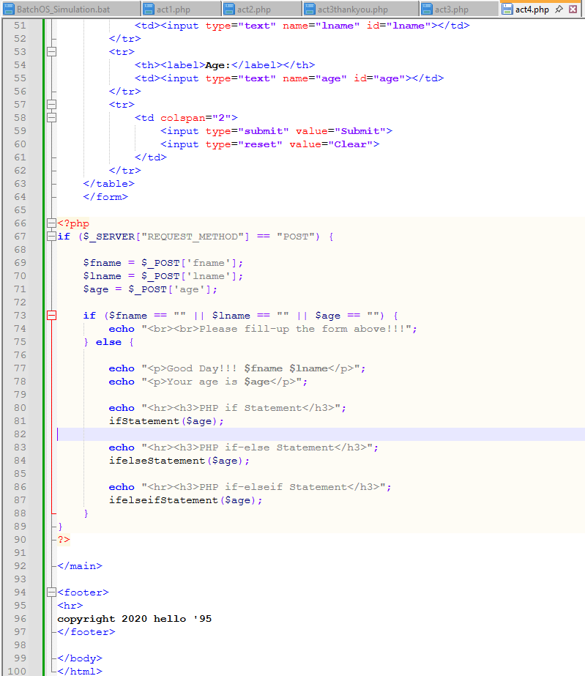
Browser Output
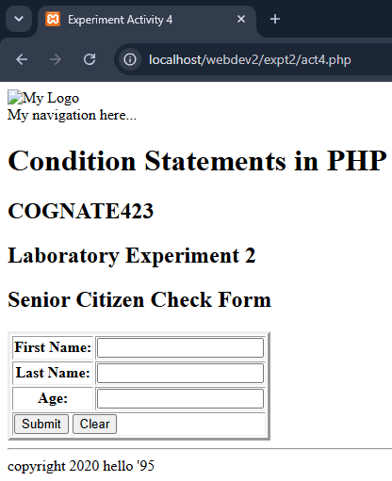
- Answer the following questions:
1. PHP Switch Statement
A PHP switch statement is a control structure used to execute different blocks of code based on the value of a single expression. It matches the result of an expression against multiple possible case values, offering a cleaner alternative to a long chain of if-elseif-else statements.
2. Advantages of PHP Switch over If-Else and If-Elseif Statements
A few advantages of using PHP Switch over If-Else and If-Elseif Statements are: First, Better Readability, it organizes multiple conditions tied to a single variable into a clean, structured layout. Second, Faster Execution, since PHP evaluates the expression only once in a switch, whereas an if-elseif chain evaluates each condition sequentially until it finds a match. Lastly, it has Easier Maintenance, by adding, removing, or modifying specific conditions which makes it simpler and less prone to syntax errors.
3. PHP Looping Statements
while Loop: Evaluates the condition before executing the code block. If the condition starts as false, the code inside the loop never runs.
do-while Loop: Executes the code block once before checking the condition. This guarantees that the code runs at least one time, even if the condition is false from the start.
for Loop: Used when you know in advance how many times the script should run. It groups initialization, condition testing, and increment/decrement operations into a single line.
foreach Loop: Designed specifically for iterating through arrays or objects. It loops through each element sequentially without requiring a manual counter.
4. Example Source Codes
a. Switch Statement
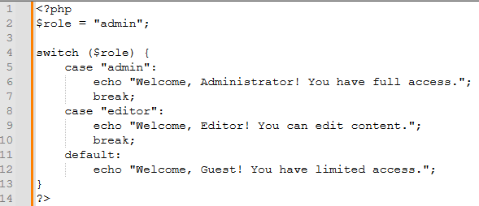
b. While loop
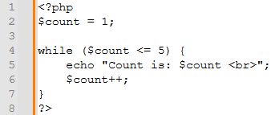
c. Do-While loop
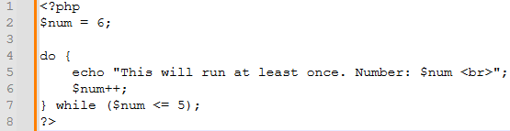
d. For loop
